Sche

CCGGA Annual Open House

Saturday, April 12, 2014

CCGGA EDUCATION CENTER SCHEDULE

[Edwards Barn 1095 Pomeroy Rd, Nipomo](http://goo.gl/maps/G6d4b)

Central Coast Greenhouse

Growers

13th Annual Scholarship

Fundraiser

Saturday April 12, 2014

9:00 am-3:00 pm

Plant/Flower Sales

& Nursery Tours

For more info: www.ccgga.com

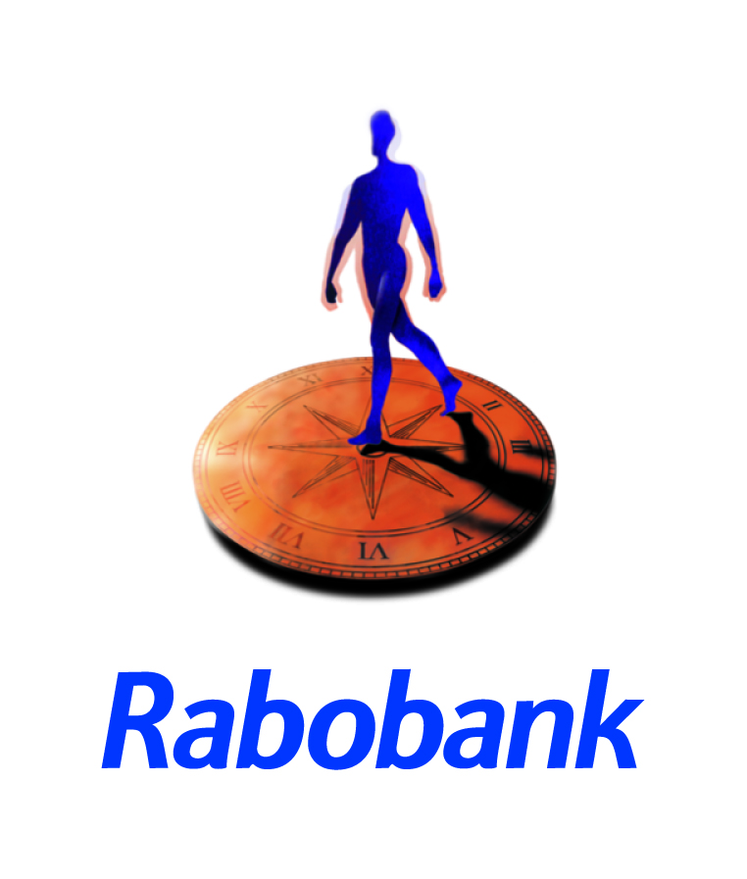

|  |
| --- |
| 10:00- 10:15 am Dave Pruitt, [ihort](http://www.ihort.com/)  *Learn how small scale hydroponics and miniature greenhouse kits can give your plugs and seeds a strong start in the garden.*    11:00-12:00 pm Ingrid Hilton, Master Food Preserver  *Don’t let the season pass you by without preserving some of your favorite fruits and veggies!*  *Learn the basics of keeping quality produce on your table year-round in this fun, family friendly canning demonstration.*  1:00-1:30 pm Tracy Cole Labastida, Chef/Owner [Field to Table Catering](http://www.fttevents.com/about/)  *Get insights and fresh ideas on how to turn your salad into the most delicious part of your meal!*  1:45-2:00 pm Dave Pruitt, [ihort](http://www.ihort.com/)  *Learn how small scale hydroponics and miniature greenhouse kits can give your plugs and seeds a strong start in the garden.* |

**You can also find at the Edwards Barn:**

* [Eufloria Flowers](http://www.eufloriaflowers.com/)

Buy fresh cut roses to enjoy at home.

* [Clearwater Nursery](http://www.clearwaternursery.com/)

Sun star, hydrangeas, calla lilies, pocketbook plants, campanula, and some hard goods.

* [SLO County Worm Farm](http://www.slocountyworms.com/)

Learn the art of brewing your own compost tea, composting with worms and much more. Demonstrations will be throughout the day.

* [Talley Farms Fresh Harvest](http://talleyfarmsfreshharvest.com/)
* [Arroyo Grande in Bloom](http://www.arroyograndeinbloom.org/)

* Vegetable and Flowers provided by Cal Seedling, Greenheart Farms, Ball Tagawa Growers, and Viva Farms.
* Soil Sales, donated by [Sun Gro Horticulture](http://www.sungro.com/)

Nipomo 4-H Breakfast ~Rotary of Nipomo BBQ

*All demos are free, family friendly and wheelchair accessible*